User Manual

**Project name**: BlockBreaker

**Students:** Anas Alagtal 14511433

Stephen Mcdonagh

**Supervisor:** Mark Roantree

**Contents**

**Summary Page 3**

**Gameplay/Goal Page 3**

**How to launch the game Page 3**

**How to play Page 4**

**Home Screen Page 4**

**Username Page 5**

**Difficulty options Page 6**

**Gameplay Page 7**

**Paddle Page 8**

**Hot to play option Page 8**

**High scores Page 10**

**Summary**:

Block breaker is my partner and I’s version of the infamous game Breakout created by Atari 1976. Many versions of the game followed but very few have the difficulty and level features that we have.

*“In the game, a layer of bricks lines the top third of the screen. A ball travels across the screen, bouncing off the top and side walls of the screen. When a brick is hit, the ball bounces away and the brick is destroyed. The player loses a life when the ball touches the bottom of the screen. To prevent this from happening, the player has a movable paddle to bounce the ball upward, keeping it in play.”* Wikipedia.

Our version of the game is identical in the gameplay, but it differs in the User experience features. Because breakout or block breaker is seen as a simple game there usually isn’t a how to play option that would provide the user or the player with the manuals and necessary keys to run and play the game. We provide this information for the players. Our game also has a high score feature that allows the player to see how well he or she did across the ranks.

**Gameplay/ Goal:**

Once launched. The aim of the game is to destroy each block on the top third of the frame row by row on a number of rows. All without losing the lives the player has.

If the ball hits either side or the top of the frame it bounces back accordingly and if it hits the bottom the player loses a life and has another attempt from where he left off if lives left are greater than 0. The user controls the bounce back of a ball by a paddle which he controls and can move left and right. If the ball hits a block, then it bounces back with the block disappearing and the score incrementing with an amount that is dependant on the difficulty. The aim is to destroy all blocks in all levels and achieve the maximum high score possible.

If the user achieves this or even a score that is relatively higher than many others, then his name, score and rank will be inputted at the beginning of the game, will be entered into the high scores database that the player can view.

**How to launch the game**

The game was developed locally and is not online there for the user has to have a copy of the code on his or her machine to be able to play. Either that or they can just take an executable file that when ran will open a jframe containing our game.

This executable file can be place on a website, so the people can easily download and play the game.

**How to play**

Once the player runs the code or the executable file the jframe is launched containing the game like stated before. It is in a menu state where the options given to the user are 1) how to play, that show the user the manuals and guidelines on how to play the game.2) A high score option that shows the player a table containing the names, ranks and score of the five top achieving players in the game in terms of the score. 3)The play option prompts the user to enter their name and then takes the player to another three options which are the difficulties. The player can choose easy, intermediate or hard. The difference in ball speed is what distinguishes one difficulty from another. Players will be rewarded with more points for choosing a harder difficulty.

The game, which was described above is a black background with yellow bricks (amount of bricks varies per level). A green ball which only begins to move once the player is ready to hit a key. Once that happens the ball moves and if it hits a block it disappears, and the score increases. Once all the blocks are destroyed then the player moves on to the following level. Once the player completes all the levels without losing all the lives then they have completed the game and their score in recorded and placed into the database

**Home Screen**

The home screen is shown below and is what first appears hen the game is ran. The different options can be clearly seen with the different colours.

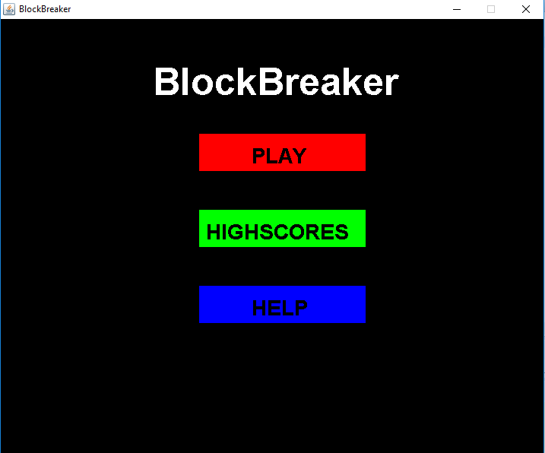

**User name**

If a user chooses to play the game they will prompted to enter their name. This will be used to show their high score at the end of the game when entered into the database.

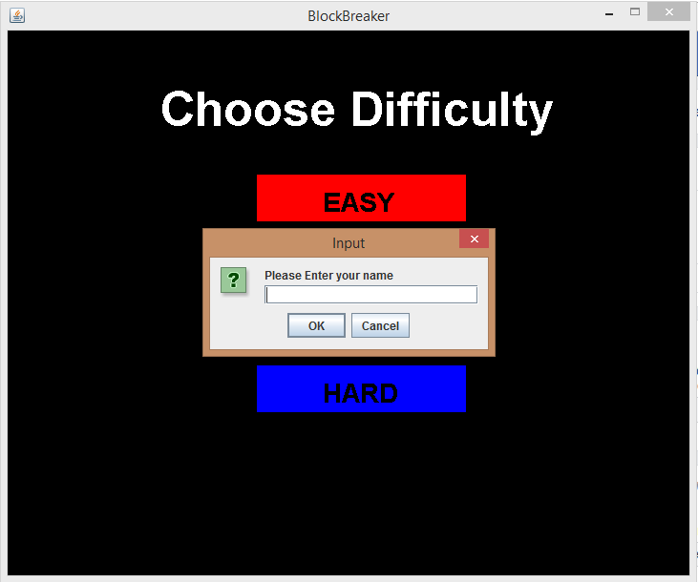

**The difficulty options:**

Below is what appears once the player chooses to play the game. They can pick between easy intermediate or hard by clicking the appropriate difficulty. Clicking each option will take the user to the appropriate difficulty type for the game.

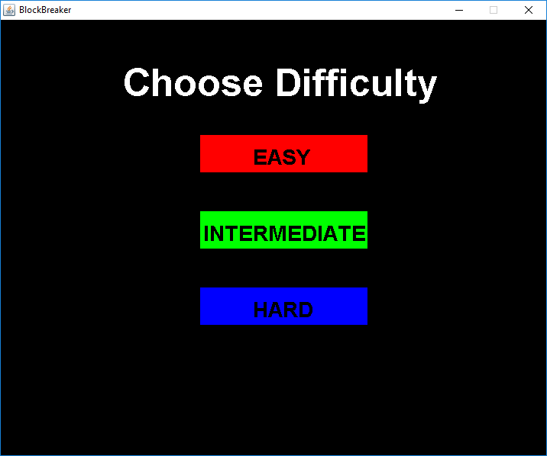

**Gameplay**

Once the user chooses what difficulty they want they are brought into the game that you can see below

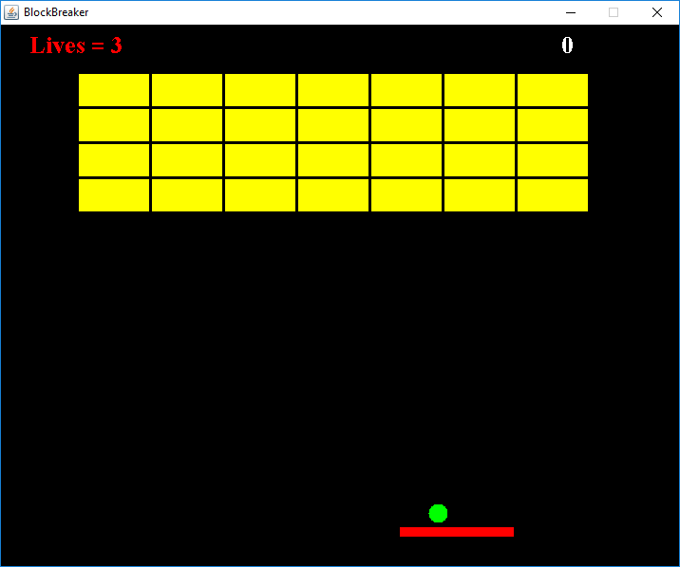

The green ball starts of on the paddle which is coloured in red above. It sits there until the user is ready to press a key. Once the player does so the ball begins to move. The map of blocks consists of a 4 by 7 blocks coloured in yellow with a small space separating each of them. The blocks stay there until the ball hits and destroy them one by one. if the ball hits the blocks, the score at the top will be increase and the ball will bounce back accordingly weather it was from the top, bottom or either side of the block. If the blocks hit the side of the frame they will also bounce in the correct direction. A player can keep the ball in play if he uses the paddle to hit the ball back up once it has come down. If the ball passes the paddle and the user is unable to bounce it back or misses it, then he/she loses a life. If the player still has a life count greater than 0, which can be seen at the top of the frame, then he/she can go again and continue playing from where they left off. Otherwise the game will exit with their score being recorded. If a player destroys al the blocks then they will be taken on to the next level. The different levels stay within the difficulty and only change in terms of block map. An example of level two below:

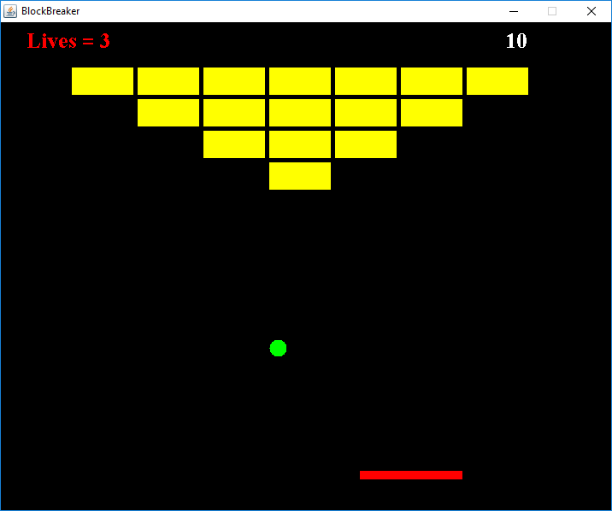

If the player completes the game then their score is recorded and placed in the database under the name they entered at the beginning.

**The paddle**

The paddle is what the user controls to bounce the ball back into the play. The game begins once the user moves the paddle. It is controlled by using the left key to move the paddle to the left and the right key to move the paddle to the right. The paddle bounds is to be with the right and left most end of the frame.

**How to play option**

Like mentioned before the how to play option take the user to a section containing the manual and some guidelines on how to play the game. It will tell the user how to enter their name, choose their difficulty, and use the controls once the game begins. It will also tell the user the aim of the game and how to beat it and reach the goal.

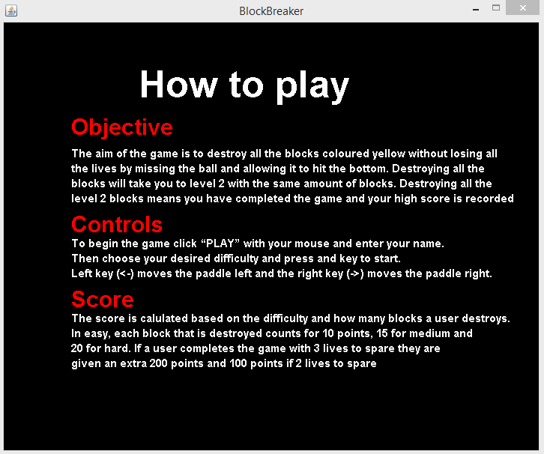

**Highscores option**

This will take the user to a section containing a table that will the show the top 5 scores achieved in the game and the names of th people that achieved them ranked from 1- 5 with 1 being the highest score. An example of this below:

